Aim: Write server-side script in PHP to perform form validation and create database application using PHP and MySQL to perform insert, update, delete and search operations.

Code:

Index.php:

<?php
require 'db.php';

$success = "";
$error = "";

// ─────────────────────────────────────────────
// INSERT
// ─────────────────────────────────────────────
if (isset($_POST['insert'])) {
$first = trim(mysqli_real_escape_string($conn, $_POST['first_name']));
$last = trim(mysqli_real_escape_string($conn, $_POST['last_name']));
$roll = trim(mysqli_real_escape_string($conn, $_POST['roll_no']));
$password = $_POST['password'];
$confirm = $_POST['confirm_password'];
$contact = trim(mysqli_real_escape_string($conn, $_POST['contact']));

// PHP Validation
if (empty($first) || empty($last) || empty($roll) || empty($password) || empty($contact)) {
$error = "All fields are required.";
} elseif (!preg_match('/^[A-Za-z ]+$/', $first) || !preg_match('/^[A-Za-z ]+$/', $last)) {
$error = "First and Last name must contain only letters.";
} elseif (strlen($password) < 6) {
$error = "Password must be at least 6 characters.";
} elseif ($password !== $confirm) {
$error = "Passwords do not match.";
} elseif (!preg_match('/^[0-9]{10}$/', $contact)) {
$error = "Contact number must be exactly 10 digits.";
} else {
// Check if Roll No already exists
$check = mysqli_query($conn, "SELECT roll_no FROM students WHERE roll_no='$roll'");
if (mysqli_num_rows($check) > 0) {
$error = "Roll No / ID '$roll' already exists.";
} else {
$hashed = password_hash($password, PASSWORD_DEFAULT);
$sql = "INSERT INTO students (first_name, last_name, roll_no, password, contact)
VALUES ('$first','$last','$roll','$hashed','$contact')";
if (mysqli_query($conn, $sql)) {
$success = "✅ Student registered successfully!";
} else {
$error = "DB Error: " . mysqli_error($conn);
}
}
}
}

// ─────────────────────────────────────────────
// DELETE
// ─────────────────────────────────────────────
if (isset($_POST['delete'])) {
$roll = trim(mysqli_real_escape_string($conn, $_POST['del_roll']));
if (empty($roll)) {
$error = "Please enter a Roll No to delete.";
} else {
$check = mysqli_query($conn, "SELECT roll_no FROM students WHERE roll_no='$roll'");
if (mysqli_num_rows($check) == 0) {
$error = "No student found with Roll No: $roll";
} else {
mysqli_query($conn, "DELETE FROM students WHERE roll_no='$roll'");
$success = "🗑️ Student with Roll No '$roll' deleted successfully.";
}
}
}

// Fetch all students
$students = mysqli_query($conn, "SELECT * FROM students ORDER BY id DESC");
?>
<!DOCTYPE html>
<html lang="en">
<head>
<meta charset="UTF-8">
<meta name="viewport" content="width=device-width, initial-scale=1.0">
<title>Student Registration System</title>
<style>
@import url('https://fonts.googleapis.com/css2?family=DM+Serif+Display&family=DM+Sans:wght@300;400;500;600&display=swap');

*, *::before, *::after { box-sizing: border-box; margin: 0; padding: 0; }

:root {
--navy: #0f1b2d;
--blue: #1a56db;
--sky: #60a5fa;
--cream: #f8f5ef;
--gold: #f59e0b;
--red: #ef4444;
--green: #10b981;
--border: #d1d5db;
--shadow: 0 4px 24px rgba(15,27,45,.12);
}

body {
font-family: 'DM Sans', sans-serif;
background: var(--cream);
color: var(--navy);
min-height: 100vh;
}

/* ── HEADER ── */
header {
background: var(--navy);
color: #fff;
padding: 0 40px;
display: flex;
align-items: center;
justify-content: space-between;
height: 70px;
position: sticky; top: 0; z-index: 100;
box-shadow: 0 2px 16px rgba(0,0,0,.3);
}
header h1 { font-family: 'DM Serif Display', serif; font-size: 1.5rem; letter-spacing: .3px; }
header span { font-size: .85rem; color: var(--sky); }

/* ── NAV TABS ── */
.tabs {
display: flex; gap: 4px;
background: #fff;
border-bottom: 2px solid var(--border);
padding: 0 40px;
}
.tab-btn {
padding: 14px 22px;
border: none; background: none;
font-family: 'DM Sans', sans-serif; font-size: .9rem; font-weight: 500;
cursor: pointer; color: #6b7280;
border-bottom: 3px solid transparent; margin-bottom: -2px;
transition: all .2s;
}
.tab-btn.active { color: var(--blue); border-bottom-color: var(--blue); }
.tab-btn:hover:not(.active) { color: var(--navy); background: var(--cream); }

/* ── SECTIONS ── */
.section { display: none; padding: 36px 40px; max-width: 1100px; margin: 0 auto; }
.section.active { display: block; animation: fadeIn .3s ease; }
@keyframes fadeIn { from { opacity:0; transform:translateY(6px) } to { opacity:1; transform:none } }

/* ── CARDS ── */
.card {
background: #fff;
border-radius: 12px;
box-shadow: var(--shadow);
padding: 32px;
margin-bottom: 28px;
}
.card-title {
font-family: 'DM Serif Display', serif;
font-size: 1.25rem;
margin-bottom: 24px;
padding-bottom: 14px;
border-bottom: 1px solid var(--border);
color: var(--navy);
}

/* ── FORM GRID ── */
.form-grid { display: grid; grid-template-columns: 1fr 1fr; gap: 18px; }
.form-group { display: flex; flex-direction: column; gap: 6px; }
.form-group.full { grid-column: span 2; }

label { font-size: .82rem; font-weight: 600; letter-spacing: .3px; color: #374151; text-transform: uppercase; }

input[type=text], input[type=password], input[type=tel], input[type=number] {
padding: 10px 14px;
border: 1.5px solid var(--border);
border-radius: 8px;
font-family: 'DM Sans', sans-serif; font-size: .95rem;
transition: border-color .2s, box-shadow .2s;
outline: none;
}
input:focus { border-color: var(--blue); box-shadow: 0 0 0 3px rgba(26,86,219,.1); }
input.error-field { border-color: var(--red); }

.field-error { font-size: .78rem; color: var(--red); margin-top: 2px; }

/* ── BUTTONS ── */
.btn {
padding: 11px 26px; border: none; border-radius: 8px;
font-family: 'DM Sans', sans-serif; font-size: .92rem; font-weight: 600;
cursor: pointer; transition: all .2s; display: inline-flex; align-items: center; gap: 6px;
}
.btn-primary { background: var(--blue); color: #fff; }
.btn-primary:hover { background: #1447c2; transform: translateY(-1px); box-shadow: 0 4px 12px rgba(26,86,219,.3); }
.btn-danger { background: var(--red); color: #fff; }
.btn-danger:hover { background: #dc2626; transform: translateY(-1px); }
.btn-warning { background: var(--gold); color: #fff; }
.btn-warning:hover { background: #d97706; transform: translateY(-1px); }

/* ── ALERTS ── */
.alert {
padding: 13px 18px; border-radius: 8px; margin-bottom: 22px;
font-weight: 500; font-size: .93rem;
}
.alert-success { background: #d1fae5; color: #065f46; border: 1px solid #a7f3d0; }
.alert-error { background: #fee2e2; color: #991b1b; border: 1px solid #fecaca; }

/* ── TABLE ── */
.table-wrap { overflow-x: auto; border-radius: 10px; border: 1px solid var(--border); }
table { width: 100%; border-collapse: collapse; font-size: .9rem; }
thead { background: var(--navy); color: #fff; }
th { padding: 13px 16px; text-align: left; font-weight: 600; font-size: .8rem; letter-spacing: .5px; text-transform: uppercase; }
td { padding: 12px 16px; border-bottom: 1px solid #f3f4f6; }
tr:last-child td { border-bottom: none; }
tr:hover td { background: #f0f4ff; }
.badge {
display: inline-block; padding: 3px 10px; border-radius: 20px;
font-size: .75rem; font-weight: 600;
background: #dbeafe; color: var(--blue);
}
.action-link {
color: var(--blue); text-decoration: none; font-weight: 600; font-size: .85rem;
padding: 4px 10px; border-radius: 5px; border: 1px solid #bfdbfe;
transition: all .15s;
}
.action-link:hover { background: var(--blue); color: #fff; }
.empty-state { text-align: center; padding: 48px; color: #9ca3af; }
.empty-state span { font-size: 2.5rem; display: block; margin-bottom: 10px; }

/* ── INLINE DELETE ROW ── */
.del-row { display: flex; gap: 12px; align-items: flex-end; flex-wrap: wrap; }
.del-row .form-group { flex: 1; min-width: 200px; }

@media(max-width:650px) {
.form-grid { grid-template-columns: 1fr; }
.form-group.full { grid-column: span 1; }
.section { padding: 20px 16px; }
header { padding: 0 16px; }
.tabs { padding: 0 8px; }
}
</style>
</head>
<body>

<header>
<h1>🎓 Student Registration System</h1>
<span>PHP CRUD &nbsp;|&nbsp; phpMyAdmin</span>
</header>

<div class="tabs">
<button class="tab-btn active" onclick="showTab('register',this)">📝 Register</button>
<button class="tab-btn" onclick="showTab('delete',this)">🗑️ Delete</button>
<button class="tab-btn" onclick="showTab('update',this)">✏️ Update</button>
<button class="tab-btn" onclick="showTab('view',this)">📋 View All</button>
</div>

<!-- ════════════════════════════════════════════
1. REGISTER
════════════════════════════════════════════ -->
<div id="register" class="section active">

<?php if ($success && isset($_POST['insert'])): ?>
<div class="alert alert-success"><?= $success ?></div>
<?php elseif ($error && isset($_POST['insert'])): ?>
<div class="alert alert-error">❌ <?= $error ?></div>
<?php endif; ?>

<div class="card">
<div class="card-title">New Student Registration</div>
<form method="POST" id="regForm" novalidate>
<div class="form-grid">

<div class="form-group">
<label>First Name *</label>
<input type="text" name="first_name" id="first_name" placeholder="e.g. Ravi"
value="<?= isset($_POST['insert']) ? htmlspecialchars($_POST['first_name']) : '' ?>">
<span class="field-error" id="err_first"></span>
</div>

<div class="form-group">
<label>Last Name *</label>
<input type="text" name="last_name" id="last_name" placeholder="e.g. Sharma"
value="<?= isset($_POST['insert']) ? htmlspecialchars($_POST['last_name']) : '' ?>">
<span class="field-error" id="err_last"></span>
</div>

<div class="form-group">
<label>Roll No / ID *</label>
<input type="text" name="roll_no" id="roll_no" placeholder="e.g. CS2024001"
value="<?= isset($_POST['insert']) ? htmlspecialchars($_POST['roll_no']) : '' ?>">
<span class="field-error" id="err_roll"></span>
</div>

<div class="form-group">
<label>Contact Number *</label>
<input type="tel" name="contact" id="contact" placeholder="10-digit mobile"
value="<?= isset($_POST['insert']) ? htmlspecialchars($_POST['contact']) : '' ?>">
<span class="field-error" id="err_contact"></span>
</div>

<div class="form-group">
<label>Password *</label>
<input type="password" name="password" id="password" placeholder="Min 6 characters">
<span class="field-error" id="err_pwd"></span>
</div>

<div class="form-group">
<label>Confirm Password *</label>
<input type="password" name="confirm_password" id="confirm_password" placeholder="Repeat password">
<span class="field-error" id="err_cpwd"></span>
</div>

<div class="form-group full" style="margin-top:8px;">
<button type="submit" name="insert" class="btn btn-primary" onclick="return validateForm()">
➕ Register Student
</button>
</div>
</div>
</form>
</div>
</div>

<!-- ════════════════════════════════════════════
2. DELETE
════════════════════════════════════════════ -->
<div id="delete" class="section">

<?php if ($success && isset($_POST['delete'])): ?>
<div class="alert alert-success"><?= $success ?></div>
<?php elseif ($error && isset($_POST['delete'])): ?>
<div class="alert alert-error">❌ <?= $error ?></div>
<?php endif; ?>

<div class="card">
<div class="card-title">Delete Student Record</div>
<form method="POST" onsubmit="return confirmDelete()">
<div class="del-row">
<div class="form-group">
<label>Roll No / ID to Delete *</label>
<input type="text" name="del_roll" id="del_roll" placeholder="Enter exact Roll No" style="width:280px">
</div>
<button type="submit" name="delete" class="btn btn-danger">🗑️ Delete Student</button>
</div>
</form>
</div>

<!-- Show current records for reference -->
<div class="card">
<div class="card-title">Current Students (Reference)</div>
<?php
$all = mysqli_query($conn, "SELECT id, first_name, last_name, roll_no, contact FROM students ORDER BY id DESC");
if (mysqli_num_rows($all) == 0): ?>
<div class="empty-state"><span>📭</span>No student records found.</div>
<?php else: ?>
<div class="table-wrap">
<table>
<thead><tr><th>#</th><th>Roll No</th><th>First Name</th><th>Last Name</th><th>Contact</th></tr></thead>
<tbody>
<?php $i=1; while($r = mysqli_fetch_assoc($all)): ?>
<tr>
<td><?= $i++ ?></td>
<td><span class="badge"><?= htmlspecialchars($r['roll_no']) ?></span></td>
<td><?= htmlspecialchars($r['first_name']) ?></td>
<td><?= htmlspecialchars($r['last_name']) ?></td>
<td><?= htmlspecialchars($r['contact']) ?></td>
</tr>
<?php endwhile; ?>
</tbody>
</table>
</div>
<?php endif; ?>
</div>
</div>

<!-- ════════════════════════════════════════════
3. UPDATE (redirects to update.php)
════════════════════════════════════════════ -->
<div id="update" class="section">
<div class="card">
<div class="card-title">Update Student Details</div>
<p style="margin-bottom:20px; color:#6b7280;">Search a student by their Roll No / ID to update their details.</p>
<form method="GET" action="update.php">
<div class="del-row">
<div class="form-group">
<label>Roll No / ID *</label>
<input type="text" name="roll_no" placeholder="Enter Roll No to search" style="width:280px" required>
</div>
<button type="submit" class="btn btn-warning">🔍 Search & Update</button>
</div>
</form>
</div>
</div>

<!-- ════════════════════════════════════════════
4. VIEW ALL
════════════════════════════════════════════ -->
<div id="view" class="section">
<div class="card">
<div class="card-title">All Student Records</div>
<?php
$all2 = mysqli_query($conn, "SELECT * FROM students ORDER BY id DESC");
if (mysqli_num_rows($all2) == 0): ?>
<div class="empty-state"><span>📭</span>No students registered yet. Go to Register tab!</div>
<?php else: ?>
<div class="table-wrap">
<table>
<thead>
<tr>
<th>#</th><th>Roll No</th><th>First Name</th>
<th>Last Name</th><th>Contact</th><th>Action</th>
</tr>
</thead>
<tbody>
<?php $i=1; while($r = mysqli_fetch_assoc($all2)): ?>
<tr>
<td><?= $i++ ?></td>
<td><span class="badge"><?= htmlspecialchars($r['roll_no']) ?></span></td>
<td><?= htmlspecialchars($r['first_name']) ?></td>
<td><?= htmlspecialchars($r['last_name']) ?></td>
<td><?= htmlspecialchars($r['contact']) ?></td>
<td>
<a href="update.php?roll_no=<?= urlencode($r['roll_no']) ?>" class="action-link">✏️ Edit</a>
</td>
</tr>
<?php endwhile; ?>
</tbody>
</table>
</div>
<?php endif; ?>
</div>
</div>

<!-- ════════════════════════════════════════════
JAVASCRIPT – Client-side Validation
════════════════════════════════════════════ -->
<script>
// Tab switching
function showTab(id, btn) {
document.querySelectorAll('.section').forEach(s => s.classList.remove('active'));
document.querySelectorAll('.tab-btn').forEach(b => b.classList.remove('active'));
document.getElementById(id).classList.add('active');
btn.classList.add('active');
}

// Auto-switch tab if there was a POST error/success
<?php
if (isset($_POST['delete'])) echo "showTab('delete', document.querySelectorAll('.tab-btn')[1]);";
if (isset($_POST['insert'])) echo "showTab('register',document.querySelectorAll('.tab-btn')[0]);";
?>

// Registration form validation
function validateForm() {
let valid = true;

const fields = {
first_name: { id:'err_first', regex:/^[A-Za-z ]+$/, msg:'Only letters allowed.' },
last_name: { id:'err_last', regex:/^[A-Za-z ]+$/, msg:'Only letters allowed.' },
roll_no: { id:'err_roll', regex:/\S+/, msg:'Roll No cannot be empty.' },
contact: { id:'err_contact', regex:/^[0-9]{10}$/, msg:'Enter a valid 10-digit number.' },
};

// Clear previous errors
document.querySelectorAll('.field-error').forEach(e => e.textContent = '');
document.querySelectorAll('input').forEach(i => i.classList.remove('error-field'));

for (const [name, rule] of Object.entries(fields)) {
const el = document.getElementById(name);
const val = el.value.trim();
if (!val) {
document.getElementById(rule.id).textContent = 'This field is required.';
el.classList.add('error-field');
valid = false;
} else if (!rule.regex.test(val)) {
document.getElementById(rule.id).textContent = rule.msg;
el.classList.add('error-field');
valid = false;
}
}

// Password checks
const pwd = document.getElementById('password');
const cpwd = document.getElementById('confirm_password');
if (pwd.value.length < 6) {
document.getElementById('err_pwd').textContent = 'Password must be at least 6 characters.';
pwd.classList.add('error-field');
valid = false;
}
if (pwd.value !== cpwd.value) {
document.getElementById('err_cpwd').textContent = 'Passwords do not match.';
cpwd.classList.add('error-field');
valid = false;
}

return valid;
}

// Delete confirmation
function confirmDelete() {
const roll = document.getElementById('del_roll').value.trim();
if (!roll) { alert('Please enter a Roll No first.'); return false; }
return confirm('Are you sure you want to delete student with Roll No: ' + roll + '?\nThis cannot be undone!');
}
</script>
</body>
</html>

Setup.sql:

-- ============================================
-- Student Registration System - Database Setup
-- Run this in phpMyAdmin > SQL tab
-- ============================================

-- Step 1: Create the database
CREATE DATABASE IF NOT EXISTS student_db;

-- Step 2: Use it
USE student_db;

-- Step 3: Create the students table
CREATE TABLE IF NOT EXISTS students (
id INT AUTO_INCREMENT PRIMARY KEY,
first_name VARCHAR(50) NOT NULL,
last_name VARCHAR(50) NOT NULL,
roll_no VARCHAR(30) NOT NULL UNIQUE,
password VARCHAR(255) NOT NULL,
contact VARCHAR(15) NOT NULL,
created_at TIMESTAMP DEFAULT CURRENT_TIMESTAMP
);

-- (Optional) Insert sample test data
INSERT INTO students (first_name, last_name, roll_no, password, contact)
VALUES
('Ravi', 'Sharma', 'CS2024001', '$2y$10$examplehash1', '9876543210'),
('Priya', 'Patel', 'CS2024002', '$2y$10$examplehash2', '9123456780'),
('Aakash', 'Mehta', 'CS2024003', '$2y$10$examplehash3', '8765432109');

Db.php:

<?php
$host = "localhost";
$user = "root";
$password = ""; // Default XAMPP password is empty
$database = "student_db";

$conn = mysqli_connect($host, $user, $password, $database, 3307);

if (!$conn) {
die("<div style='color:red; font-family:sans-serif; padding:20px;'>
❌ Database Connection Failed: " . mysqli_connect_error() . "
<br><br>Make sure:<br>
1. XAMPP MySQL is running<br>
2. You've created the database (see setup instructions)
</div>");
}
?>

Update.php:

<?php
require 'db.php';

$student = null;
$success = "";
$error = "";
$search_roll = isset($_GET['roll_no']) ? trim($_GET['roll_no']) : (isset($_POST['search_roll']) ? trim($_POST['search_roll']) : '');

// ─────────────────────────────────────────────
// SEARCH student
// ─────────────────────────────────────────────
if (!empty($search_roll)) {
$safe = mysqli_real_escape_string($conn, $search_roll);
$res = mysqli_query($conn, "SELECT * FROM students WHERE roll_no='$safe'");
if (mysqli_num_rows($res) > 0) {
$student = mysqli_fetch_assoc($res);
} else {
$error = "No student found with Roll No: " . htmlspecialchars($search_roll);
}
}

// ─────────────────────────────────────────────
// UPDATE student
// ─────────────────────────────────────────────
if (isset($_POST['update'])) {
$roll = trim(mysqli_real_escape_string($conn, $_POST['roll_no']));
$first = trim(mysqli_real_escape_string($conn, $_POST['first_name']));
$last = trim(mysqli_real_escape_string($conn, $_POST['last_name']));
$contact = trim(mysqli_real_escape_string($conn, $_POST['contact']));
$new_pwd = $_POST['new_password'];
$confirm = $_POST['confirm_password'];

// PHP Validation
if (empty($first) || empty($last) || empty($contact)) {
$error = "First name, Last name and Contact are required.";
} elseif (!preg_match('/^[A-Za-z ]+$/', $first) || !preg_match('/^[A-Za-z ]+$/', $last)) {
$error = "Names must contain only letters.";
} elseif (!preg_match('/^[0-9]{10}$/', $contact)) {
$error = "Contact must be exactly 10 digits.";
} elseif (!empty($new_pwd) && strlen($new_pwd) < 6) {
$error = "New password must be at least 6 characters.";
} elseif (!empty($new_pwd) && $new_pwd !== $confirm) {
$error = "Passwords do not match.";
} else {
if (!empty($new_pwd)) {
$hashed = password_hash($new_pwd, PASSWORD_DEFAULT);
$sql = "UPDATE students SET first_name='$first', last_name='$last',
contact='$contact', password='$hashed' WHERE roll_no='$roll'";
} else {
$sql = "UPDATE students SET first_name='$first', last_name='$last',
contact='$contact' WHERE roll_no='$roll'";
}
if (mysqli_query($conn, $sql)) {
$success = "✅ Student record updated successfully!";
// Re-fetch updated student
$res2 = mysqli_query($conn, "SELECT * FROM students WHERE roll_no='$roll'");
$student = mysqli_fetch_assoc($res2);
$search_roll = $roll;
} else {
$error = "DB Error: " . mysqli_error($conn);
}
}

// Keep student populated on error
if ($error) {
$safe = mysqli_real_escape_string($conn, $roll);
$res3 = mysqli_query($conn, "SELECT * FROM students WHERE roll_no='$safe'");
$student = mysqli_fetch_assoc($res3);
$search_roll = $roll;
}
}
?>
<!DOCTYPE html>
<html lang="en">
<head>
<meta charset="UTF-8">
<meta name="viewport" content="width=device-width, initial-scale=1.0">
<title>Update Student – Student Registration System</title>
<style>
@import url('https://fonts.googleapis.com/css2?family=DM+Serif+Display&family=DM+Sans:wght@300;400;500;600&display=swap');

*, *::before, *::after { box-sizing: border-box; margin: 0; padding: 0; }

:root {
--navy: #0f1b2d; --blue: #1a56db; --sky: #60a5fa;
--cream: #f8f5ef; --gold: #f59e0b; --red: #ef4444; --green: #10b981;
--border: #d1d5db; --shadow: 0 4px 24px rgba(15,27,45,.12);
}

body { font-family:'DM Sans',sans-serif; background:var(--cream); color:var(--navy); min-height:100vh; }

header {
background:var(--navy); color:#fff; padding:0 40px;
display:flex; align-items:center; justify-content:space-between;
height:70px; box-shadow:0 2px 16px rgba(0,0,0,.3);
}
header h1 { font-family:'DM Serif Display',serif; font-size:1.4rem; }
header a { color:var(--sky); text-decoration:none; font-size:.88rem; transition:color .2s; }
header a:hover { color:#fff; }

.container { max-width:820px; margin:0 auto; padding:36px 40px; }

.card { background:#fff; border-radius:12px; box-shadow:var(--shadow); padding:32px; margin-bottom:24px; }
.card-title { font-family:'DM Serif Display',serif; font-size:1.2rem; margin-bottom:22px;
padding-bottom:14px; border-bottom:1px solid var(--border); }

.search-row { display:flex; gap:12px; align-items:flex-end; flex-wrap:wrap; }
.form-group { display:flex; flex-direction:column; gap:6px; }
.form-group.flex1 { flex:1; min-width:200px; }

.form-grid { display:grid; grid-template-columns:1fr 1fr; gap:18px; }
.form-group.full { grid-column:span 2; }

label { font-size:.82rem; font-weight:600; letter-spacing:.3px; color:#374151; text-transform:uppercase; }

input[type=text],input[type=password],input[type=tel] {
padding:10px 14px; border:1.5px solid var(--border); border-radius:8px;
font-family:'DM Sans',sans-serif; font-size:.95rem; outline:none; transition:border-color .2s,box-shadow .2s;
}
input:focus { border-color:var(--blue); box-shadow:0 0 0 3px rgba(26,86,219,.1); }
input.error-field { border-color:var(--red); }
input[readonly] { background:#f9fafb; color:#6b7280; cursor:default; }

.field-error { font-size:.78rem; color:var(--red); margin-top:2px; }

.btn { padding:11px 26px; border:none; border-radius:8px; font-family:'DM Sans',sans-serif;
font-size:.92rem; font-weight:600; cursor:pointer; transition:all .2s;
display:inline-flex; align-items:center; gap:6px; }
.btn-primary { background:var(--blue); color:#fff; }
.btn-primary:hover { background:#1447c2; transform:translateY(-1px); box-shadow:0 4px 12px rgba(26,86,219,.3); }
.btn-warning { background:var(--gold); color:#fff; }
.btn-warning:hover { background:#d97706; }
.btn-outline { background:transparent; border:2px solid var(--navy); color:var(--navy); }
.btn-outline:hover { background:var(--navy); color:#fff; }

.alert { padding:13px 18px; border-radius:8px; margin-bottom:22px; font-weight:500; font-size:.93rem; }
.alert-success { background:#d1fae5; color:#065f46; border:1px solid #a7f3d0; }
.alert-error { background:#fee2e2; color:#991b1b; border:1px solid #fecaca; }

.student-badge {
display:inline-flex; align-items:center; gap:8px;
background:#eff6ff; border:1px solid #bfdbfe; border-radius:8px;
padding:8px 16px; margin-bottom:20px; font-size:.9rem; color:var(--blue);
}
.note { font-size:.82rem; color:#6b7280; margin-top:6px; }

@media(max-width:650px) {
.form-grid { grid-template-columns:1fr; }
.form-group.full { grid-column:span 1; }
.container { padding:20px 16px; }
header { padding:0 16px; }
}
</style>
</head>
<body>

<header>
<h1>✏️ Update Student Record</h1>
<a href="index.php">← Back to Dashboard</a>
</header>

<div class="container">

<?php if ($success): ?>
<div class="alert alert-success"><?= $success ?></div>
<?php elseif ($error && !$student): ?>
<div class="alert alert-error">❌ <?= $error ?></div>
<?php endif; ?>

<!-- SEARCH FORM -->
<div class="card">
<div class="card-title">🔍 Find Student by Roll No</div>
<form method="GET" action="update.php">
<div class="search-row">
<div class="form-group flex1">
<label>Roll No / ID</label>
<input type="text" name="roll_no" placeholder="e.g. CS2024001"
value="<?= htmlspecialchars($search_roll) ?>" required>
</div>
<button type="submit" class="btn btn-warning">🔍 Search</button>
<a href="index.php" class="btn btn-outline">Cancel</a>
</div>
</form>
</div>

<!-- UPDATE FORM (shown only when student found) -->
<?php if ($student): ?>
<div class="card">
<div class="card-title">Update Details</div>

<?php if ($error && $student): ?>
<div class="alert alert-error">❌ <?= $error ?></div>
<?php endif; ?>

<div class="student-badge">
🎓 Editing: <strong><?= htmlspecialchars($student['first_name'].' '.$student['last_name']) ?></strong>
&nbsp;|&nbsp; Roll No: <strong><?= htmlspecialchars($student['roll_no']) ?></strong>
</div>

<form method="POST" action="update.php" id="updForm" novalidate>
<input type="hidden" name="roll_no" value="<?= htmlspecialchars($student['roll_no']) ?>">
<input type="hidden" name="search_roll" value="<?= htmlspecialchars($student['roll_no']) ?>">

<div class="form-grid">

<div class="form-group">
<label>First Name *</label>
<input type="text" name="first_name" id="u_first"
value="<?= htmlspecialchars(isset($_POST['first_name']) ? $_POST['first_name'] : $student['first_name']) ?>">
<span class="field-error" id="err_first"></span>
</div>

<div class="form-group">
<label>Last Name *</label>
<input type="text" name="last_name" id="u_last"
value="<?= htmlspecialchars(isset($_POST['last_name']) ? $_POST['last_name'] : $student['last_name']) ?>">
<span class="field-error" id="err_last"></span>
</div>

<div class="form-group">
<label>Roll No (Read-only)</label>
<input type="text" value="<?= htmlspecialchars($student['roll_no']) ?>" readonly>
</div>

<div class="form-group">
<label>Contact Number *</label>
<input type="tel" name="contact" id="u_contact"
value="<?= htmlspecialchars(isset($_POST['contact']) ? $_POST['contact'] : $student['contact']) ?>">
<span class="field-error" id="err_contact"></span>
<span class="note">Update your 10-digit mobile number</span>
</div>

<div class="form-group">
<label>New Password <small style="text-transform:none;font-weight:400">(leave blank to keep current)</small></label>
<input type="password" name="new_password" id="u_pwd" placeholder="New password (optional)">
<span class="field-error" id="err_pwd"></span>
</div>

<div class="form-group">
<label>Confirm New Password</label>
<input type="password" name="confirm_password" id="u_cpwd" placeholder="Repeat new password">
<span class="field-error" id="err_cpwd"></span>
</div>

<div class="form-group full" style="margin-top:8px; display:flex; gap:12px; flex-wrap:wrap;">
<button type="submit" name="update" class="btn btn-primary" onclick="return validateUpdate()">
💾 Save Changes
</button>
<a href="index.php" class="btn btn-outline">Cancel</a>
</div>
</div>
</form>
</div>
<?php endif; ?>

</div>

<script>
function validateUpdate() {
let valid = true;
document.querySelectorAll('.field-error').forEach(e => e.textContent='');
document.querySelectorAll('input:not([readonly])').forEach(i => i.classList.remove('error-field'));

const first = document.getElementById('u_first');
const last = document.getElementById('u_last');
const contact = document.getElementById('u_contact');
const pwd = document.getElementById('u_pwd');
const cpwd = document.getElementById('u_cpwd');

if (!first.value.trim()) {
document.getElementById('err_first').textContent = 'Required.'; first.classList.add('error-field'); valid=false;
} else if (!/^[A-Za-z ]+$/.test(first.value.trim())) {
document.getElementById('err_first').textContent = 'Letters only.'; first.classList.add('error-field'); valid=false;
}
if (!last.value.trim()) {
document.getElementById('err_last').textContent = 'Required.'; last.classList.add('error-field'); valid=false;
} else if (!/^[A-Za-z ]+$/.test(last.value.trim())) {
document.getElementById('err_last').textContent = 'Letters only.'; last.classList.add('error-field'); valid=false;
}
if (!/^[0-9]{10}$/.test(contact.value.trim())) {
document.getElementById('err_contact').textContent = 'Enter a valid 10-digit number.';
contact.classList.add('error-field'); valid=false;
}
if (pwd.value && pwd.value.length < 6) {
document.getElementById('err_pwd').textContent = 'Min 6 characters.'; pwd.classList.add('error-field'); valid=false;
}
if (pwd.value && pwd.value !== cpwd.value) {
document.getElementById('err_cpwd').textContent = 'Passwords do not match.'; cpwd.classList.add('error-field'); valid=false;
}
return valid;
}
</script>
</body>
</html>

Output:

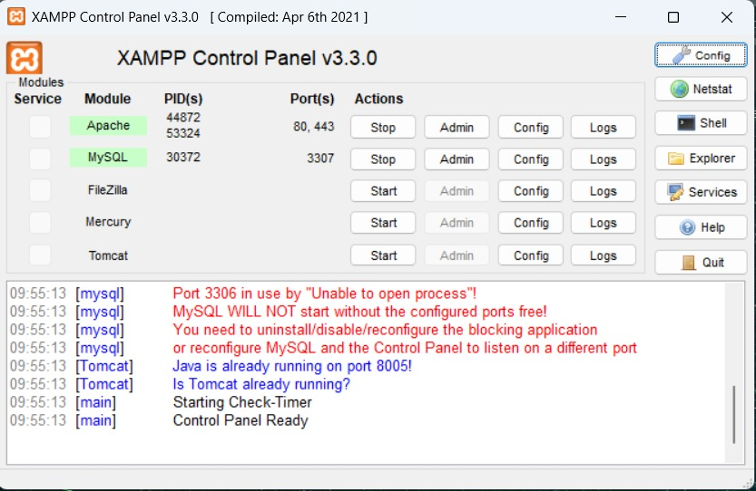
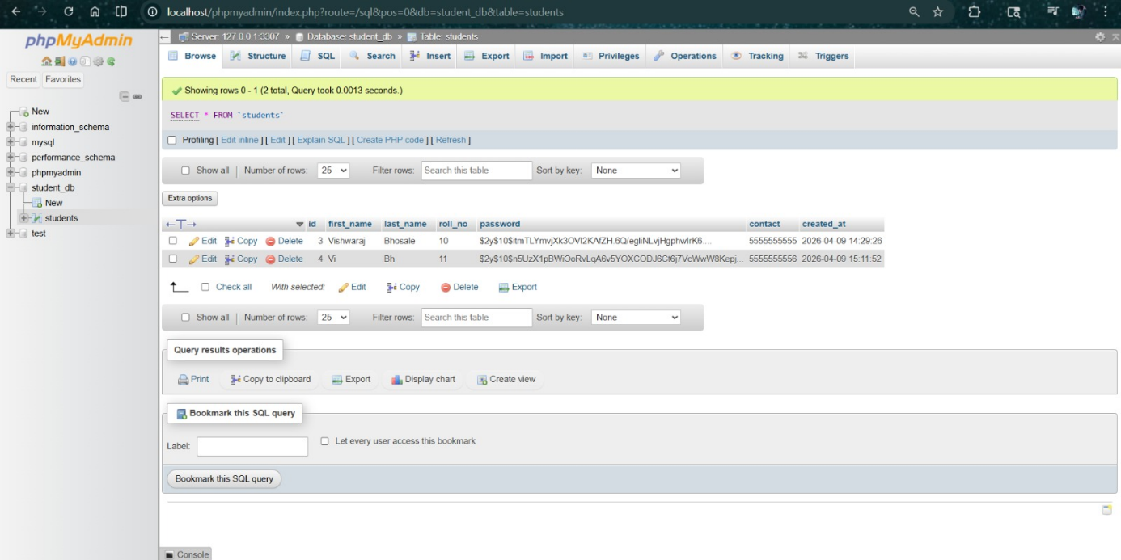
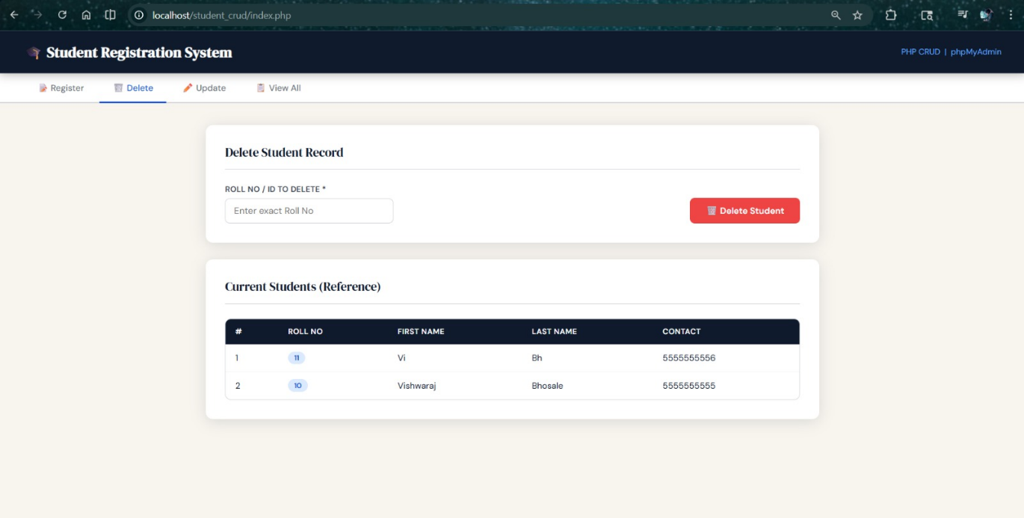
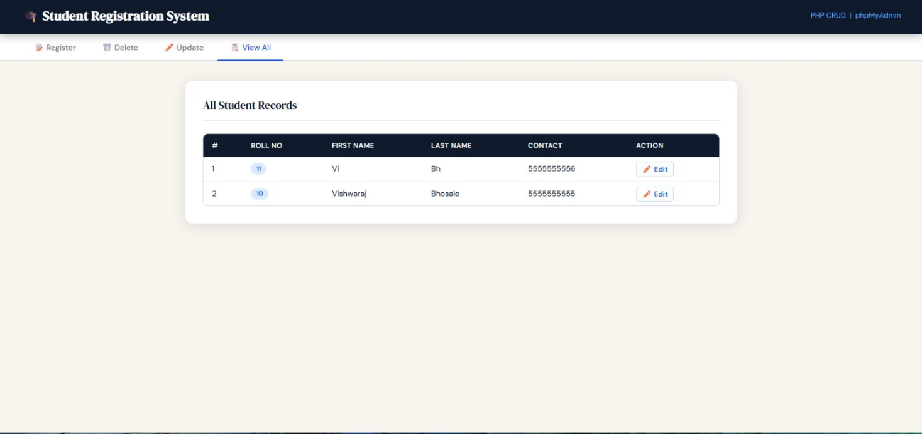

FAQ:
